Personal Affairs Checklist

This is a confidential document. Keep it in a safe place at all times.

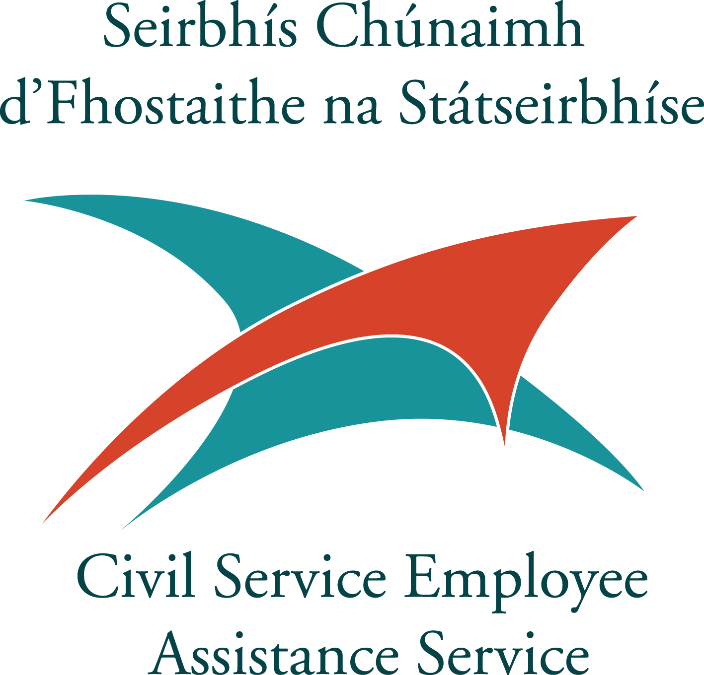
Contents

PART 1 1
Glossary of Terms 1
Introduction 2
Purpose of this booklet 2
Civil Service Employee Assistance Service (CSEAS) 2
Other sources of information and advice 2
Making a Will 3

PART 2 4
My Personal Details 4
Social Welfare details 4
Contact Details of my Legal Personal Representative(s) 5
Details of my Will 5
My Employment Details 6
Group and Scheme Memberships 7
My Personal Documents 8
Bank /Building Society/ Post Office Account(s) details 9
Credit Union Account details 10
Stocks / Shares/ Investment details 10
Credit Cards 11
Car Details 11
Other Assets 11
Home Utilities 12
Miscellaneous additional information 12

PART 1 Glossary of Terms

Civil Status
This means being single, married, separated, divorced, widowed, in a civil partnership within the meaning of the Civil Partnership and Certain Rights and Obligations of Cohabitants Act 2010 or being a former civil partner in a civil partnership that has ended by death or been dissolved.
Estate
The term used to describe all the deceased person’s belongings. This includes property, money and personal belongings; in fact everything that has to be distributed after death.

Legal Personal Representative
Person who deals with the administration of the estate of a deceased person
i.e. generic term for both executors and administrators.

Testator
This means a person who makes a Will.

Executor
Person named by testator to prove his/her Will and administer his/her estate.

Administrator
Person appointed to administer an estate where the deceased did not leave a Will.

Codicil
This is a document for adding to, altering, or confirming a Will previously made by the testator.

Grant of Probate
Legal document obtained from the Probate Office proving the Will and entitling the executor to administer the estate.

Grant of Administration
Legal document obtained from the Probate Office proving entitlement of the next-of-kin to administer the estate where the person died without making a Will.

Inheritance - Refers to a transfer of an asset by a person on death under Capital Acquisition Tax law.

Disclaimer: The contents of this booklet are informative only and are not intended to be legally binding or to convey legal advice. Neither the Department of Public Expenditure & Reform, nor its agents accept any liability in relation to the operation of these matters. The Department of Public Expenditure & Reform is not responsible for any consequences that may be caused directly or indirectly by the content within this booklet or from external websites mentioned herein. The contents have been compiled on the basis of information available as at October 2013.
Introduction

Purpose of this booklet:
This booklet has been produced by the Civil Service Employee Assistance Service (CSEAS) for civil servants. It provides a means of recording concise details of your personal affairs and papers. The information contained therein may be useful to family/next-of-kin in the event of your death.
PART 2 of this booklet can be completed by you as a detailed record of your personal affairs and papers.
It is advisable to keep your completed document in a safe and secure place. If you choose to save this booklet electronically (when completed) please ensure it is saved to a secure area on your computer where it can be easily accessed by family/next-of-kin in the event of your death.

Civil Service Employee Assistance Service (CSEAS)
The CSEAS is a centralised service within the Department of Public Expenditure and Reform (DPER). Services and support are provided on a regional basis to civil servants which aim to positively enhance their wellbeing. This Service is an important component of an ethos of promoting employee wellness, resilience and organisational effectiveness.

Upon the death of a serving civil servant the Civil Service Employee Assistance Service is available to provide practical information, advice and support to the family of the deceased civil servant.
Telephone: 0761 000 030
Email: cseas@per.gov.ie
Website: www.cseas.per.gov.ie

Other sources of information and advice:

Citizens Information www.citizensinformation.ie
- Civil Service Pensions Information Centre www.cspensions.gov.ie
- Dept. of Employment Affairs & Social Protection www.welfare.ie
- Health Service Executive www.hse.ie
- Pensions Ombudsman www.pensionsombudsman.ie
- Probate information www.courts.ie
- Revenue www.revenue.ie
- Office of the Registrar General www.welfare.ie
- Think ahead www.thinkahead.ie

The following links can only be accessed through civil service work-place computers. The relevant contact phone numbers are included:

- Peoplepoint www.peoplepoint.gov.ie Phone: 0761 071 000
- Payroll Shared Service www.pssc.gov.ie Phone: 0761 002 702

Making a Will:
It is prudent that you engage a qualified solicitor to assist you in drawing up and supervising the execution of your Will.
The main reasons for making a Will are:
- You choose who may act as your Executor to administer your assets after your death. It is prudent that you appoint at least two executors, both of whom should be competent in their roles, younger than you and respected in your family to ensure your estate is administered properly and without dispute as soon as possible after your death.

- You decide who will inherit your estate.
Making a Will allows you decide how your assets with be administered. It allows you distribute your assets in the most tax efficient manner possible, having regard to the relevant tax thresholds and reliefs of the various beneficiaries in your estate.

Check www.revenue.ie for further information on Capital Acquisitions Tax thresholds applicable to inheritances.

Information on probate is available at www.courts.ie

PART 2

My Personal Details

Name | Date of Birth

Home Address
Civil Status* see page 1 – Glossary of Terms

Spouse’s/Civil Partner’s/Partner’s Name

Children’s Names | Date of Birth:

Do you have an adult child with special needs?  If Yes, please provide details under Children (above) | Yes No

Social Welfare details

PPSN

Social Welfare payment or pension (if applicable)
Social Welfare Claim No.
(if applicable)

Contact Details of my Legal Personal Representative(s)

Name and Address of my Legal Personal Representative (No.1) | Contact ph. no./email address
Name and Address of my Legal Personal Representative (No.2) | Contact ph. no./email address

Details of my Will

I have made a Will – please tick | Yes No
My Will is placed with/at

Date of my Last Will & Testament

Codicil to my Will & date (if any)
Contact details of my Solicitor:
Name & Address

Contact number/email address

My Employment Details

Employer
(former employer, if retired)
Employer’s Address

Employer’s Registered Number
Employer’s Ph. no.
Personnel/Payroll No.
PSSC Pension No.
(if retired)
PPSN
(see P.60/Tax Certificate)
Social Insurance Class
(see Note below)

Directorship(s) held - please tick  Name & Address of company  Tax Ref. No. | Yes No
Note:
- Most established civil servants recruited prior to 6th April 1995 pay social insurance at Class B rate.
- Most civil servants recruited to established posts on or after 6th April 1995 pay social insurance at Class A rate.
- All non-established civil servants pay Class A rate.
- Most un-established civil servants pay social insurance at Class A rate.
- Social insurance Class D rate applies to permanent and pensionable employees in the public service other than those paying Class B and Class C (Army) recruited prior to 6th April 1995.
- Check www.welfare.ie for Social Welfare benefits under the various social insurance classes.

Group and Scheme Memberships

Membership - please tick
Civil Service Spouse’s & Children’s Pension Scheme | YES | NO
Civil Service Credit Union | YES | NO
Cana Credit Union (Revenue staff only) | YES | NO
Hospital Saturday Fund | YES | NO
Public Service Friendly Society | YES | NO
An Post National Instalment Savings Scheme | YES | NO
An Post Savings Account | YES | NO
Private Health Insurance  Company Name: | YES | NO
Income Continuance Plan  Company Name: | YES | NO
Life Assurance Policy  Company Name: | YES | NO
Additional Voluntary Contribution Scheme  Company Name: | YES | NO
Trade Union  Please specify : | YES | NO
Prize Bonds (list the numbers below) | YES | NO
Other group scheme  Please specify: | YES | NO

My Personal Documents

Document held | Tick here
Birth Certificate

Marriage Certificate
Civil Partnership Certificate
Divorce/Separation/Civil Partnership Dissolution docs.

Passport

Life Assurance policies

Insurance policies as follows -

House insurance

Car insurance

Mortgage Protection

Others

Property Deed(s) as follows -

Family home

Other properties & addresses
(e.g. farmland)

Mortgage paper(s)

Grave plot papers

Medical Card
(if held)

Bank /Building Society Account(s) Details
Bank/Building Society
(if joint account state other account holder’s name)
Address

Account(s) details
- IBAN
- BIC
Account(s) details
- IBAN
- BIC
Account(s) details
- IBAN
- BIC

Bank/Building Society
(if joint account, state other account holder’s name)
Address

Account(s) details
- IBAN
- BIC
Account(s) details
- IBAN
- BIC
Account(s) details
- IBAN
- BIC

Post Office Account details

Post Office Name & Address

Account(s) details

Credit Union Account details

Credit Union Name & Address

Account(s) details

Credit Cards

Credit Card Company & Address

Credit Card Account(s) details

Stocks/Shares/Investment Details

Company Name(s) & Address(es)

Stocks/ shares/Investment details

Car Details

Car Make, Model & Reg. No.

Motor Insurance Co. & Address

Motor Insurance Policy No.

Other Assets
(e.g. Jewellery, Artwork, Collectibles, Boat)

Home Utilities

Utility Item | Supplier | Account No.
- Electricity
- Gas
- Telephone (mobile)
- Telephone (landline)
- TV network provider
- WiFi/Broadband
- TV Licence
- Refuse Collection
- Dog Licence

Miscellaneous additional information

Date of completion of this document: _______________________________
Signed: ______________________________________

